**WEEK 6- REACT HANDS-ON**

**EXERCISE 1:**

**CODE:**

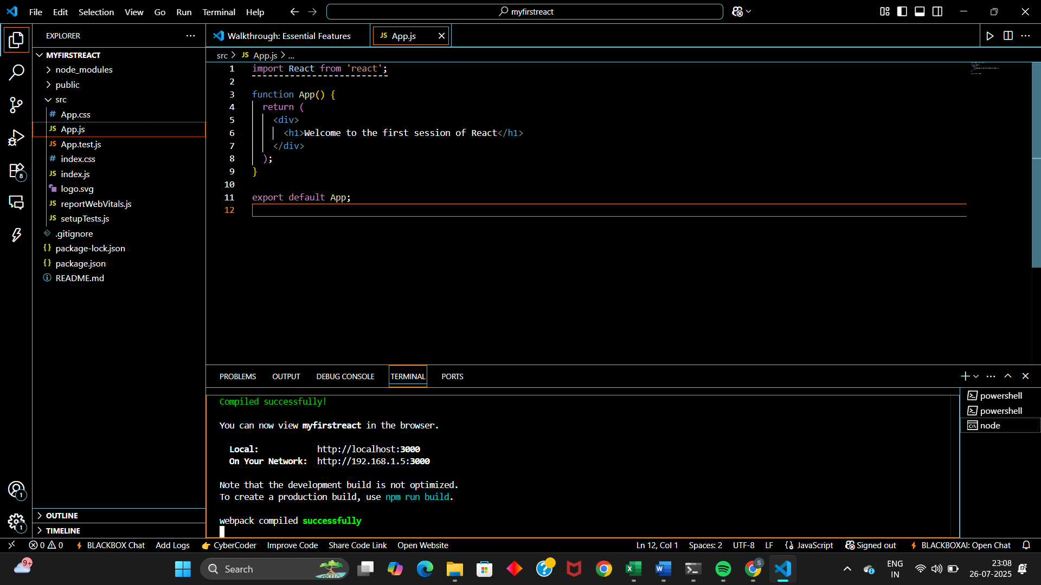

**RESULT:**

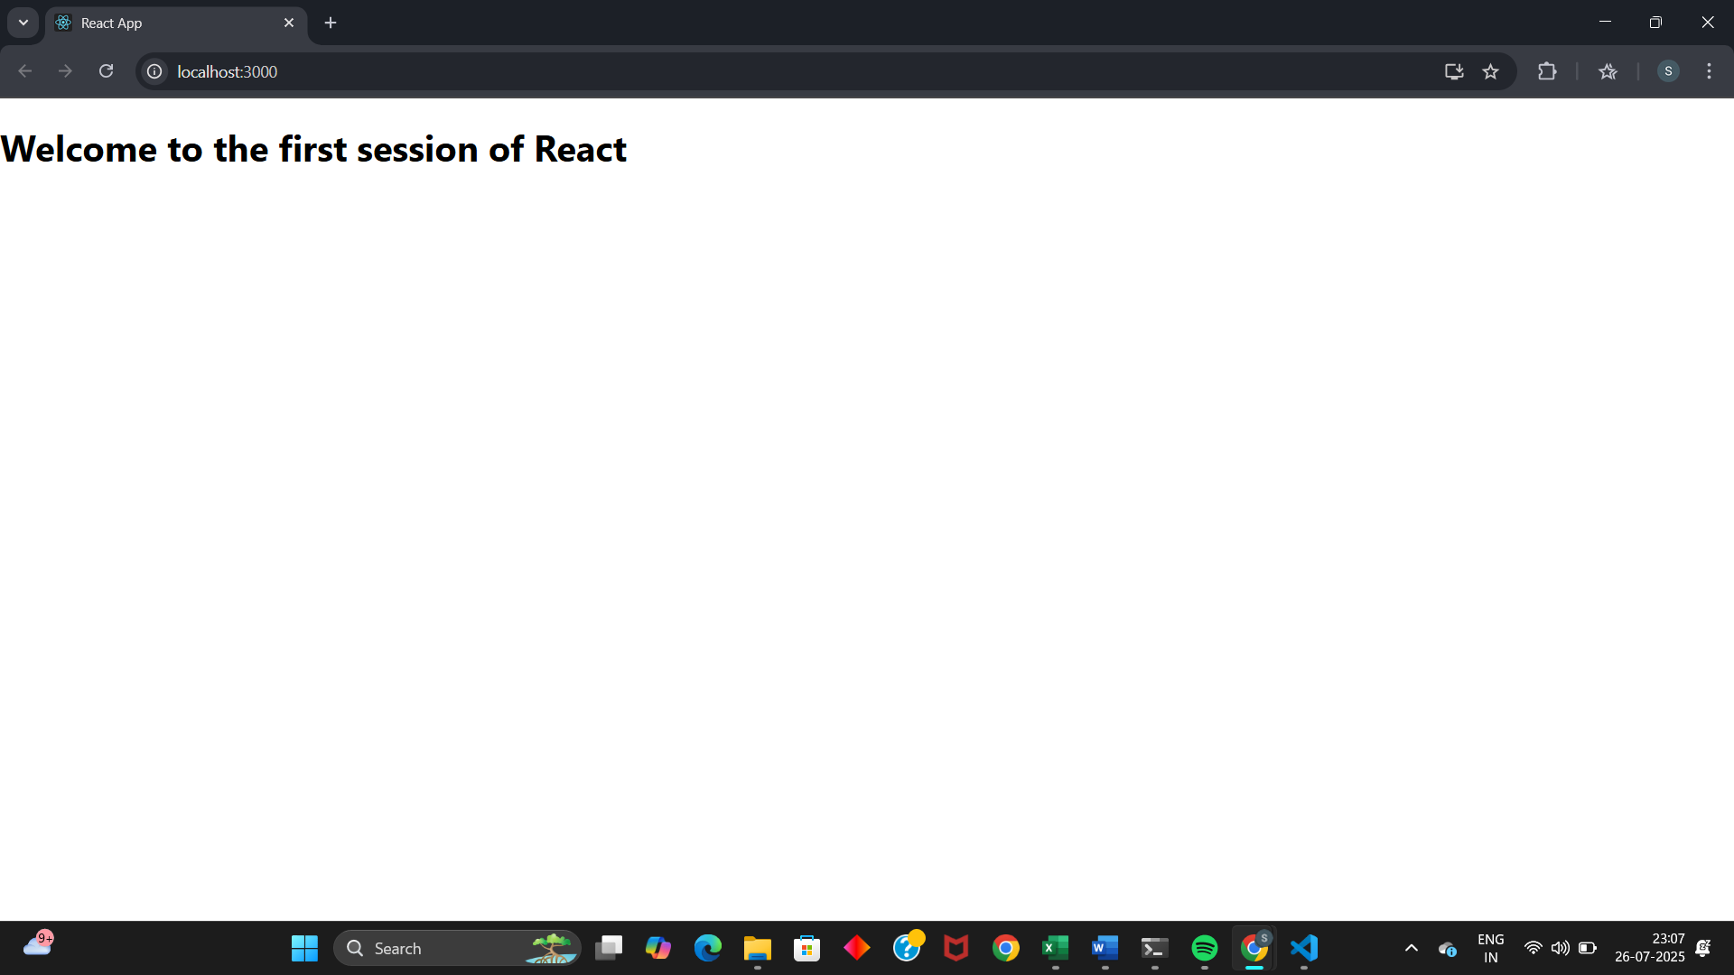

**EXERCISE 2: Student Management Portal**

**CODE:  
Home.js File:  
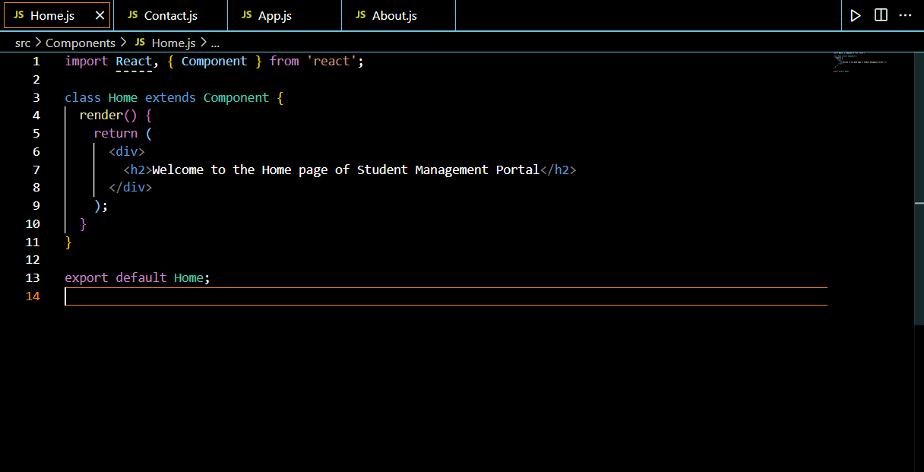**

**Contact.js File:  
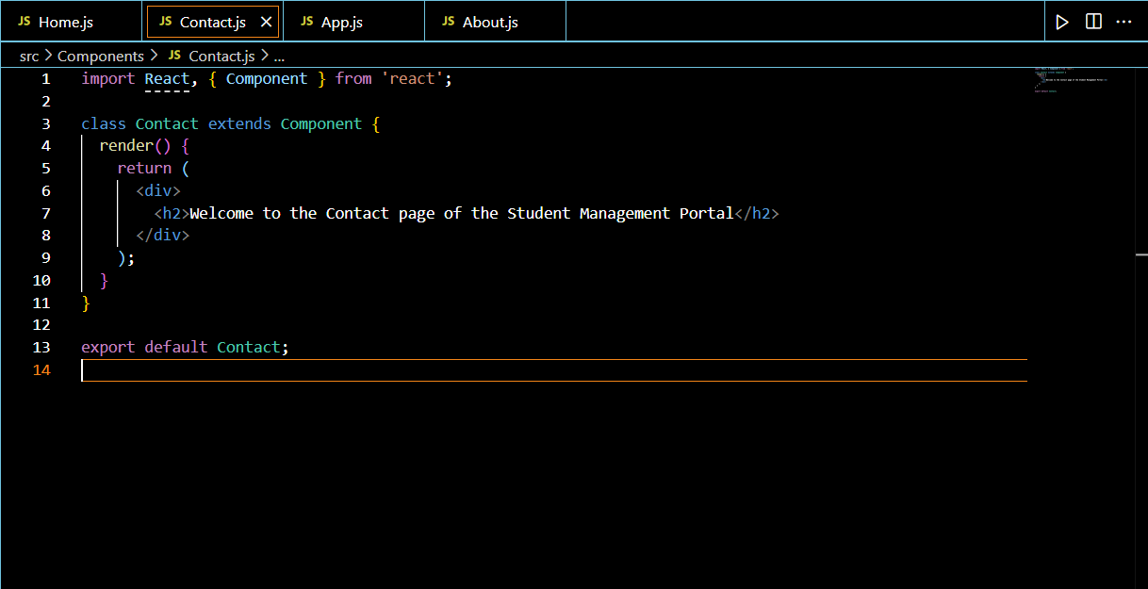**

**About.js File:  
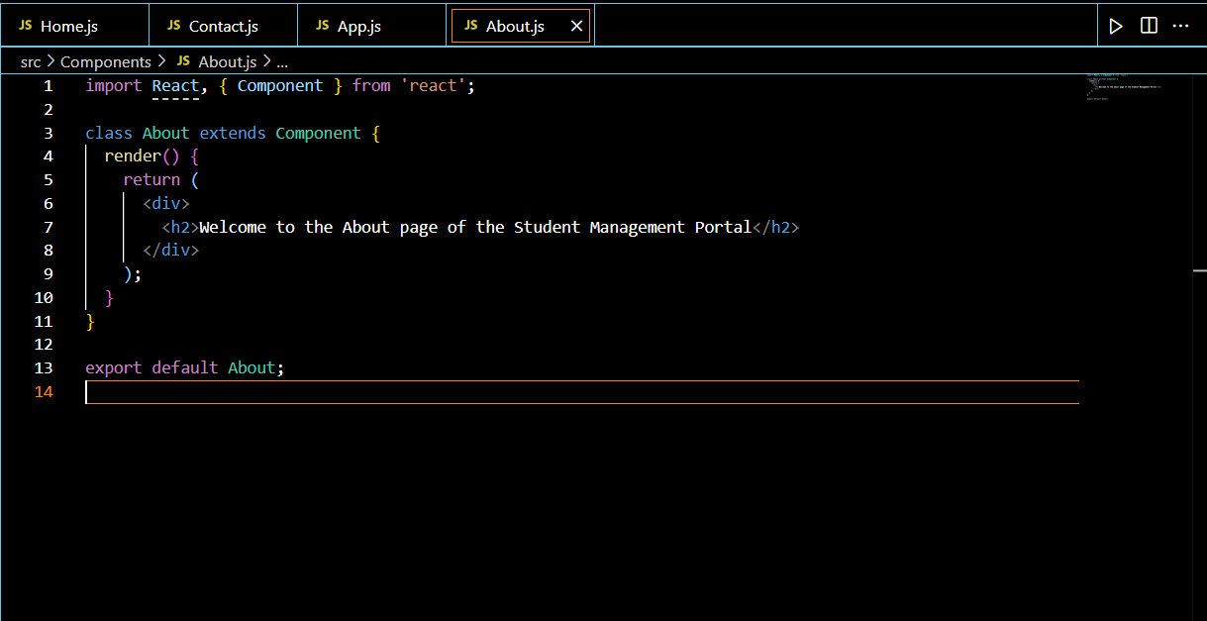**

**App.js File:**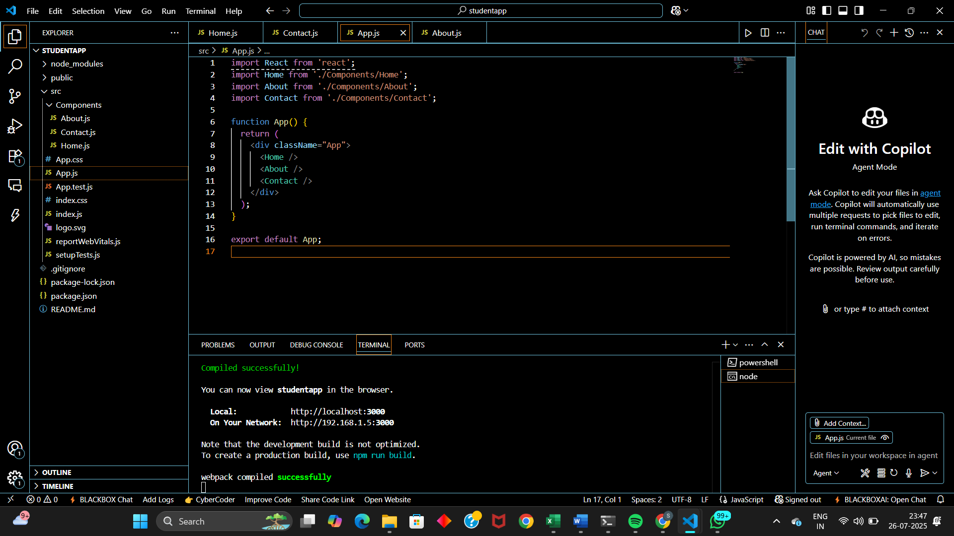

**RESULT:**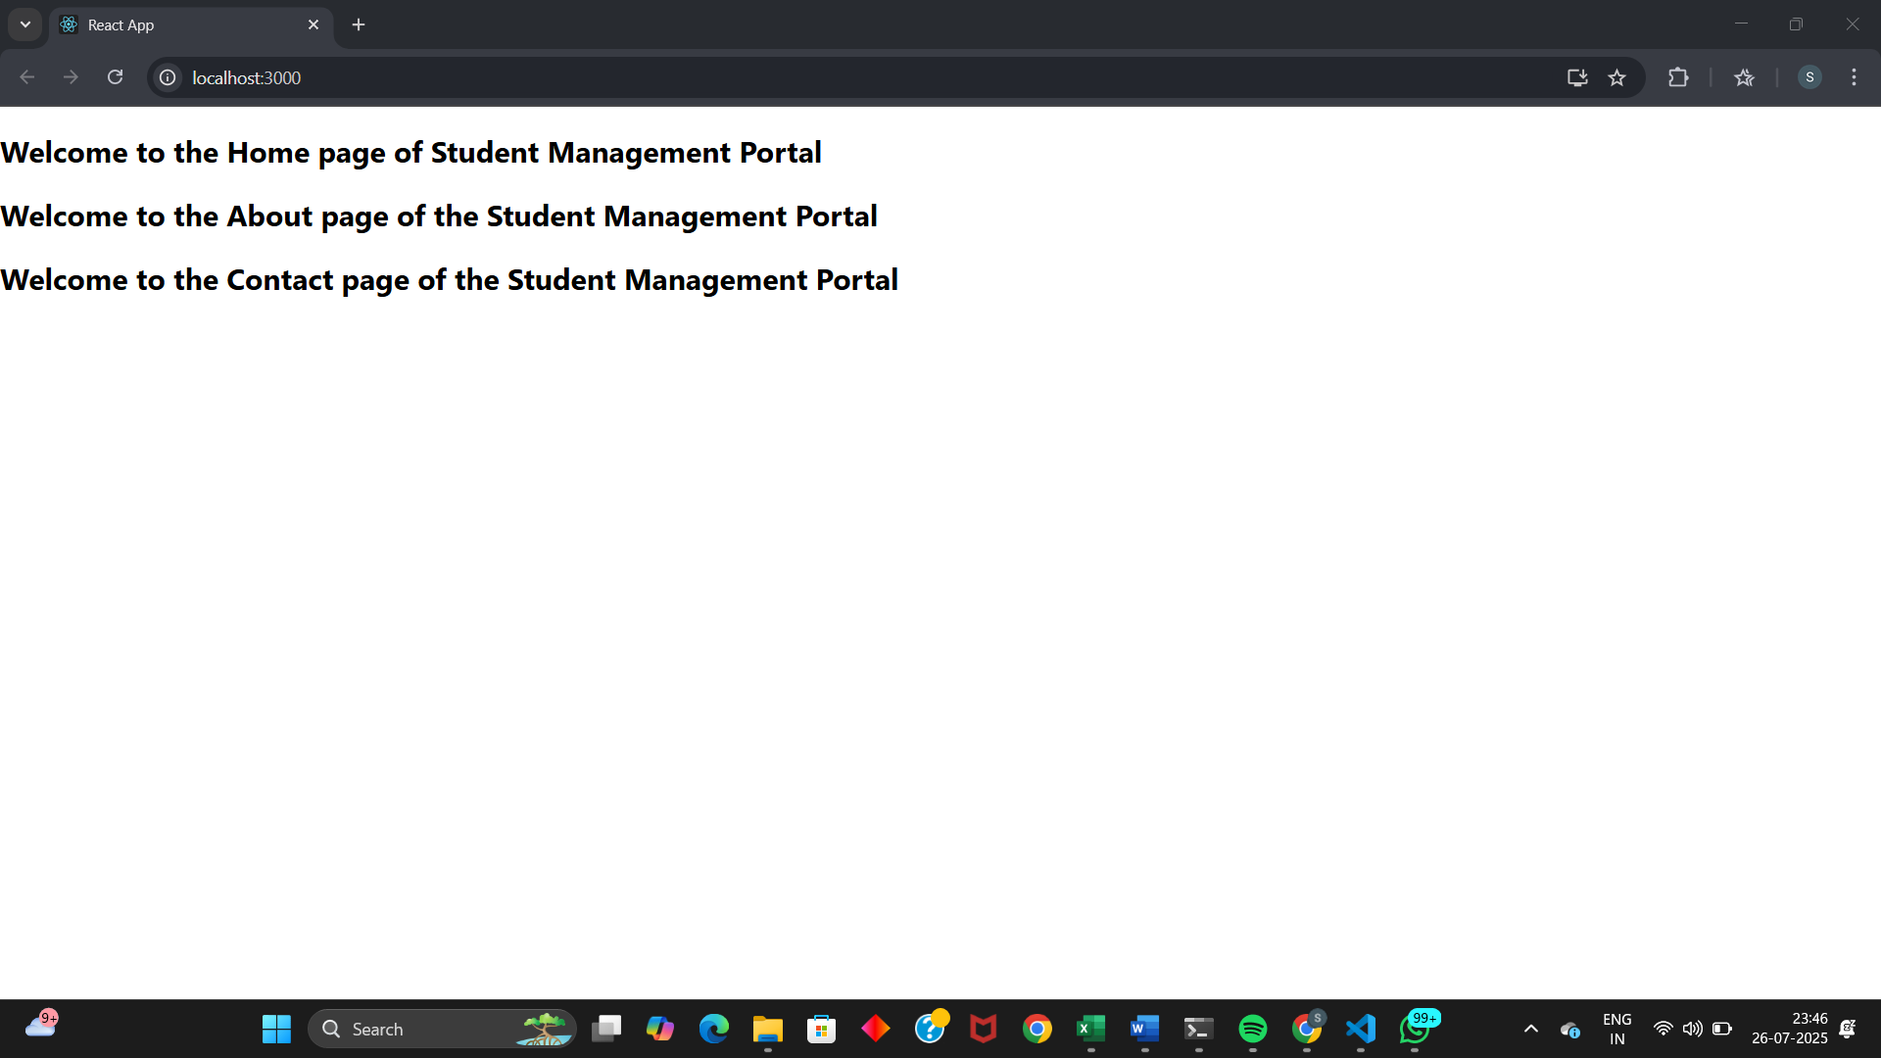

**EXERCISE 3: Calculate Score App**

**CODE:**

**CalculateScore.js:  
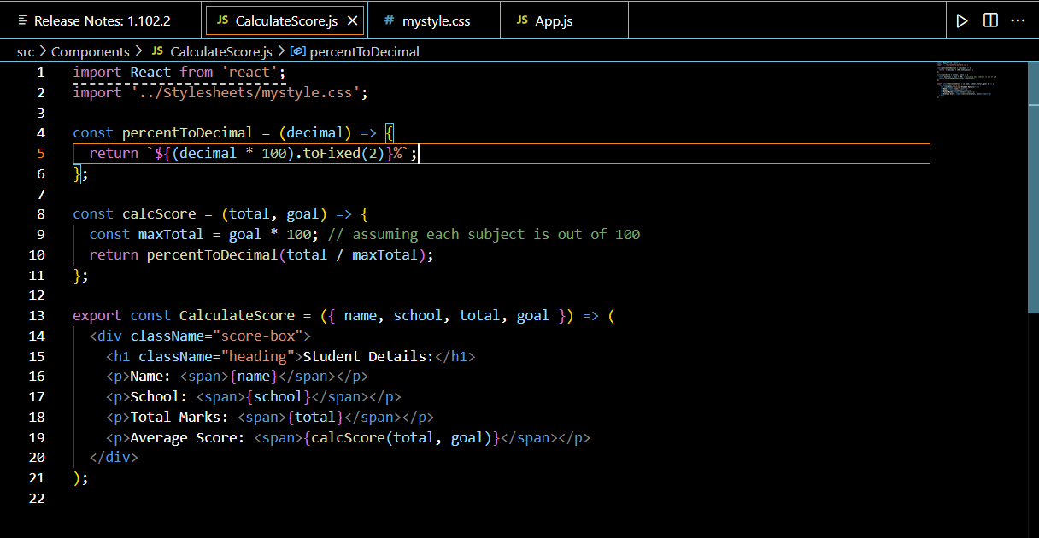**

**mystyle.css:  
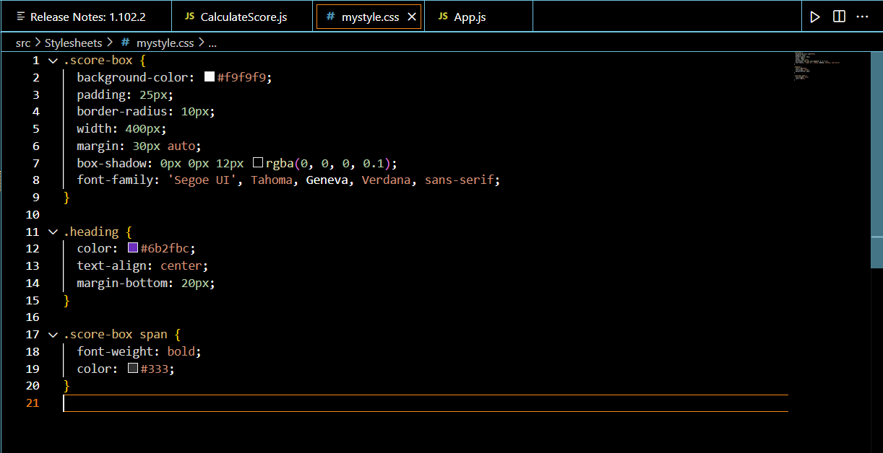**

**App.js:  
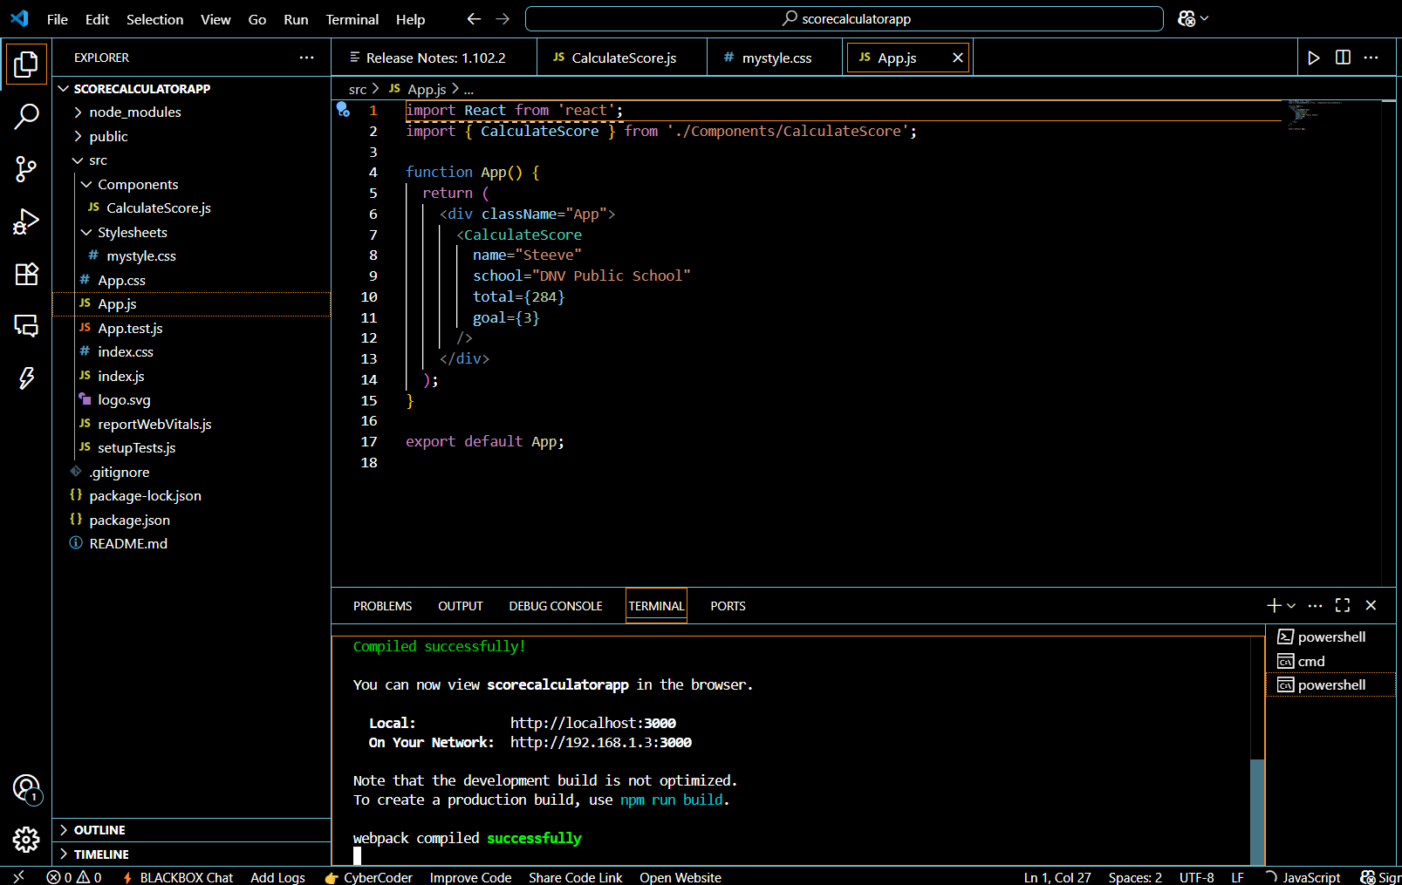**

**RESULT:**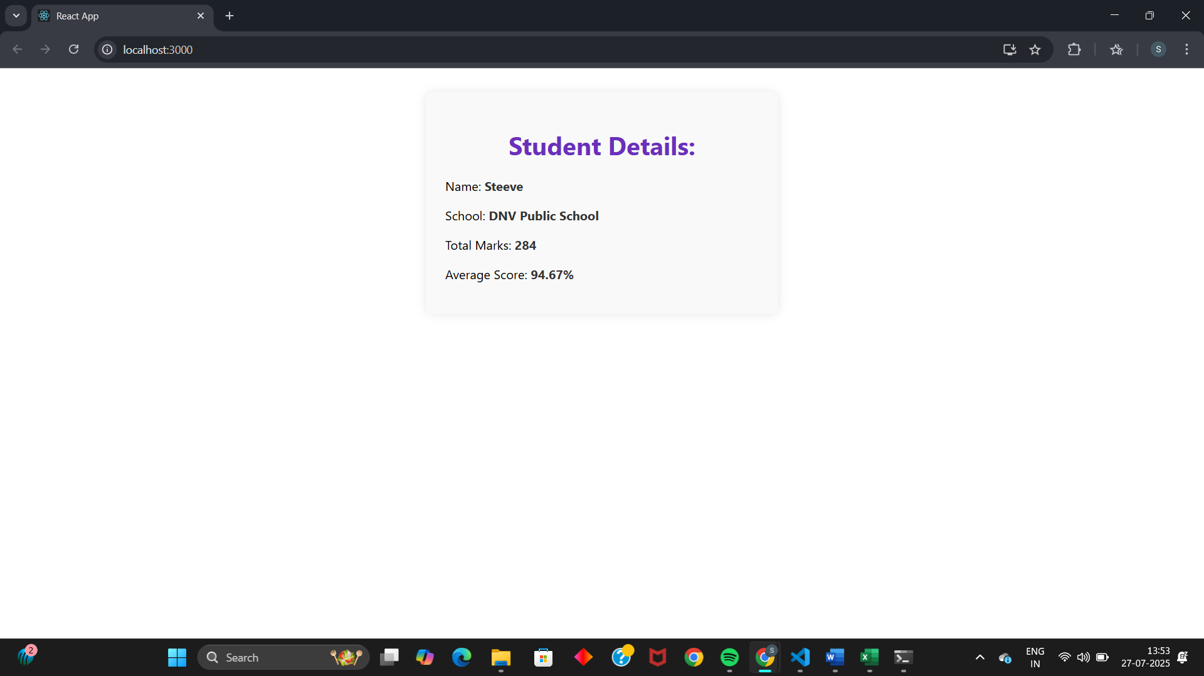

**EXERCISE 4:**

**CODE:**

**Post.js:  
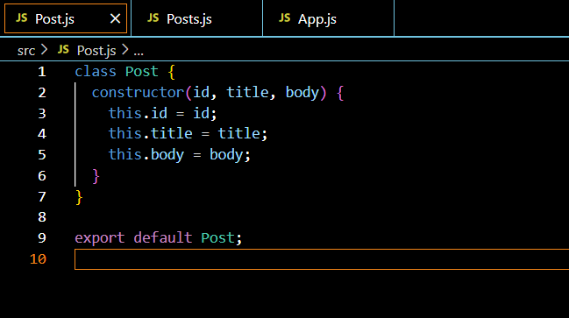**

**Post.js:**

import React from 'react';

import Post from './Post';

class Posts extends React.Component {

  constructor(props) {

    super(props);

    this.state = {

      posts: [],

      error: null

    };

  }

  loadPosts() {

    fetch('https://jsonplaceholder.typicode.com/posts')

      .then(response => {

        if (!response.ok) {

          throw new Error('Network response was not ok');

        }

        return response.json();

      })

      .then(data => {

        const postList = data.map(p => new Post(p.id, p.title, p.body));

        this.setState({ posts: postList });

      })

      .catch(error => {

        this.setState({ error });

      });

  }

  componentDidMount() {

    this.loadPosts();

  }

  componentDidCatch(error, info) {

    alert(`Error occurred: ${error.toString()}`);

    console.error("Error Info:", info);

  }

  render() {

    if (this.state.error) {

      return <h2>Error loading posts.</h2>;

    }

    return (

      <div>

        <h1>Blog Posts</h1>

        {this.state.posts.map(post => (

          <div key={post.id} style={{ border: "1px solid gray", marginBottom: "10px", padding: "10px" }}>

            <h3>{post.title}</h3>

            <p>{post.body}</p>

          </div>

        ))}

      </div>

    );

  }

}

export default Posts;

**App.js:  
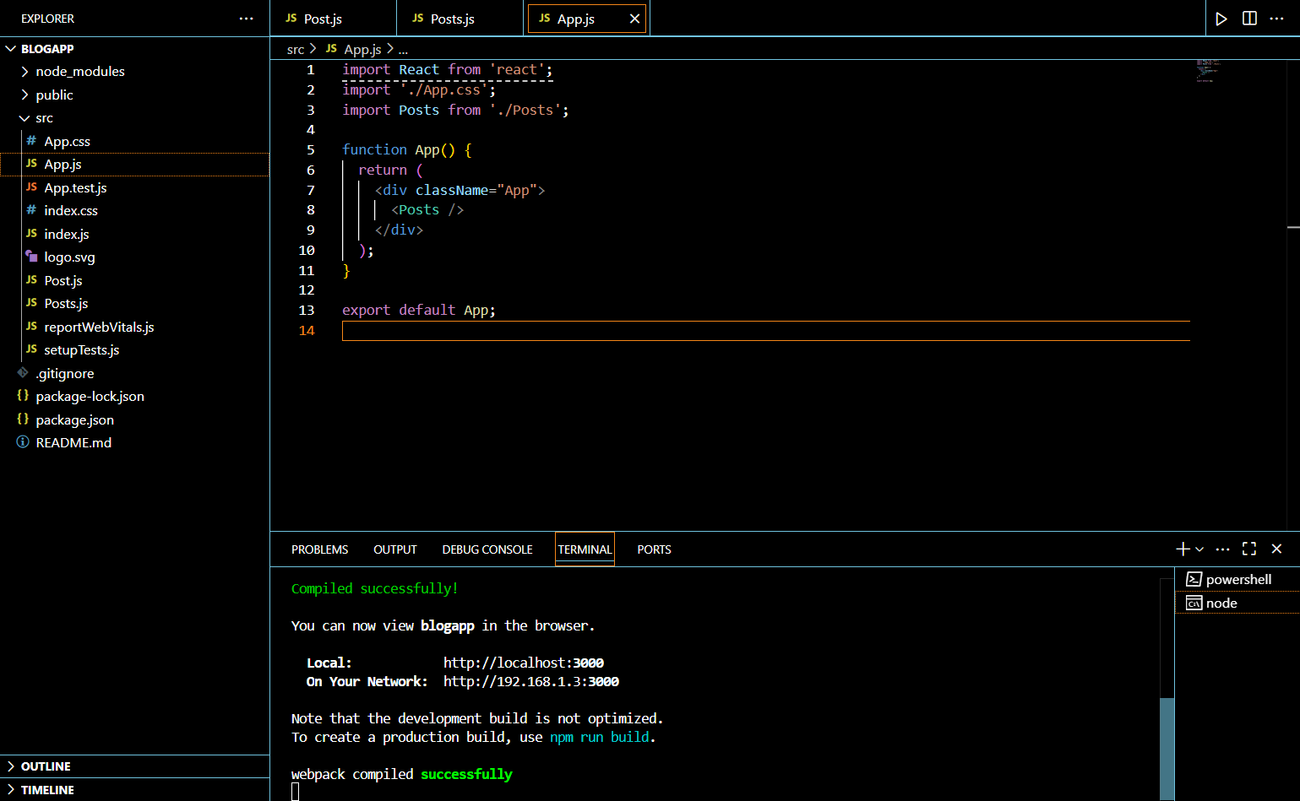**

**RESULT:**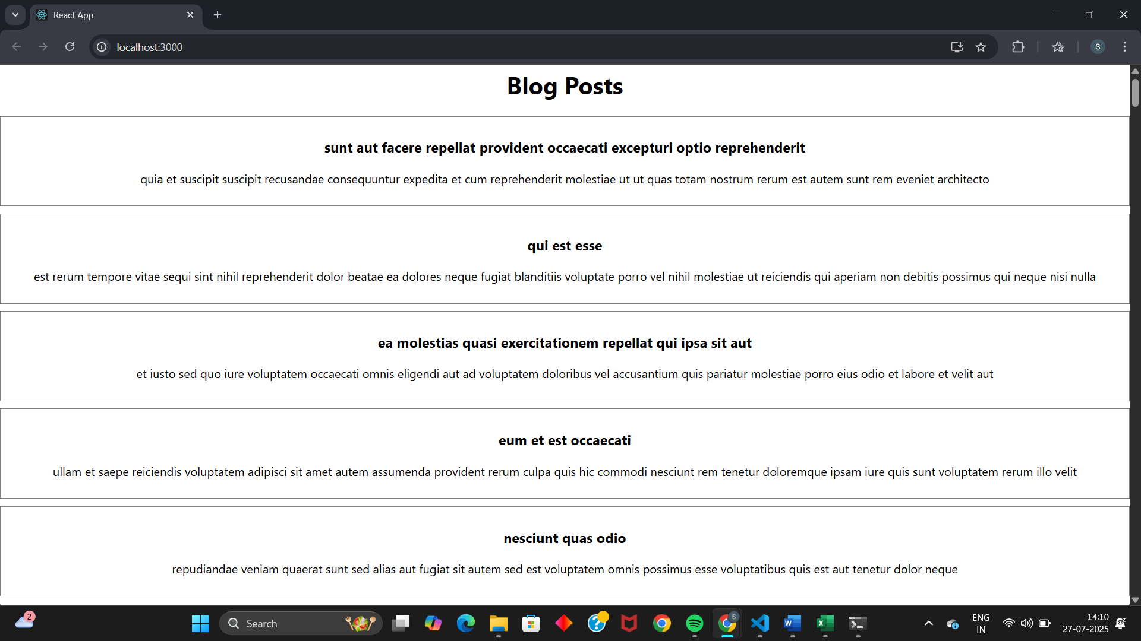

**EXERCISE 5:**

**CODE:**

**CohortDetails.js:  
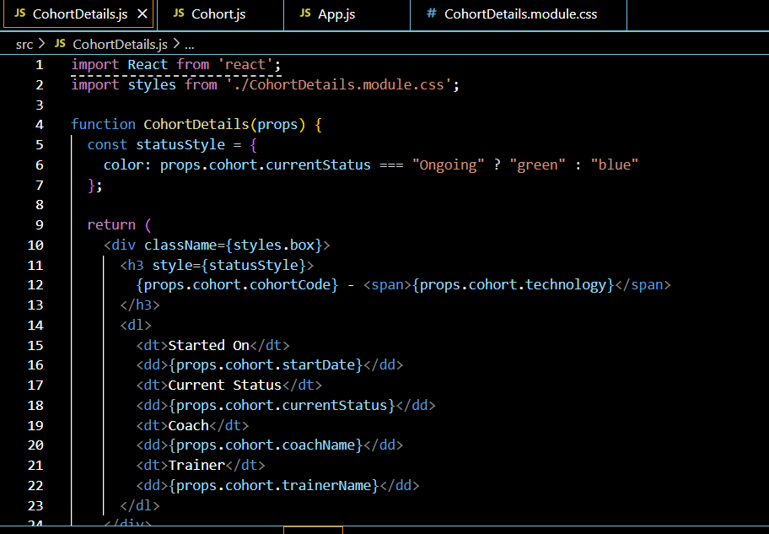  
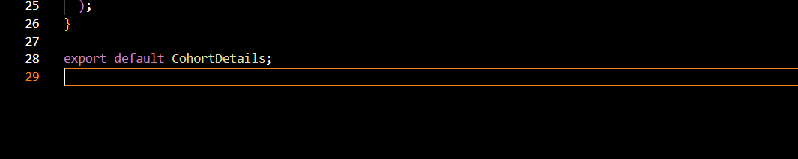**

**Cohort.module.css:  
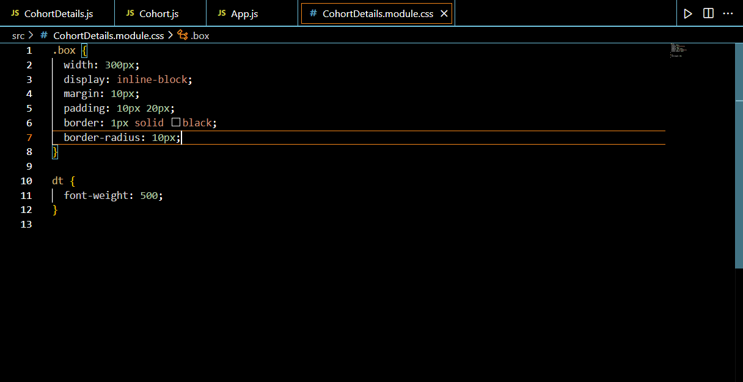**

**App.js:  
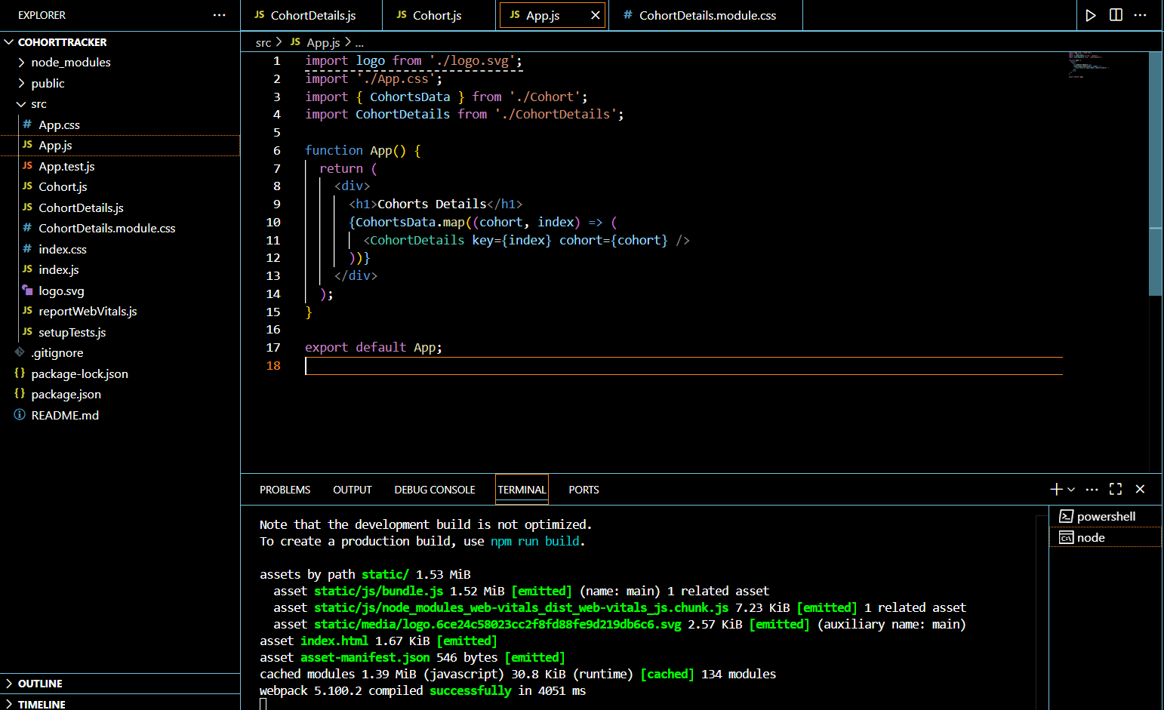**

**RESULT:**

